**Assignment 4:**

Write SQL statements to CREATE a new database and tables that reflect the library schema you designed earlier. Use ALTER statements to modify the table structures and DROP statements to remove a redundant table.

Tables used to design library system.

* Library
* Book
* Author
* Member
* Book Author

Constraints:

* **Primary Keys**: Unique identification for each record in the table.
* **Foreign Keys**: Establish relationships between tables.
* **NOT NULL**: Field must have a value.
* **UNIQUE**: Field must have unique values.
* **CHECK**: Ensuring that a field's value meets a specific condition.

**SQL Commands to create Tables and Relations:**

**Library Table:**

CREATE TABLE Library (

LibraryID INT PRIMARY KEY NOT NULL,

LibraryName VARCHAR(80) NOT NULL,

Address VARCHAR(120) NOT NULL,

PhoneNumber INT check (PhoneNumber > 9 AND PhoneNumber <= 13)NOT NULL

);

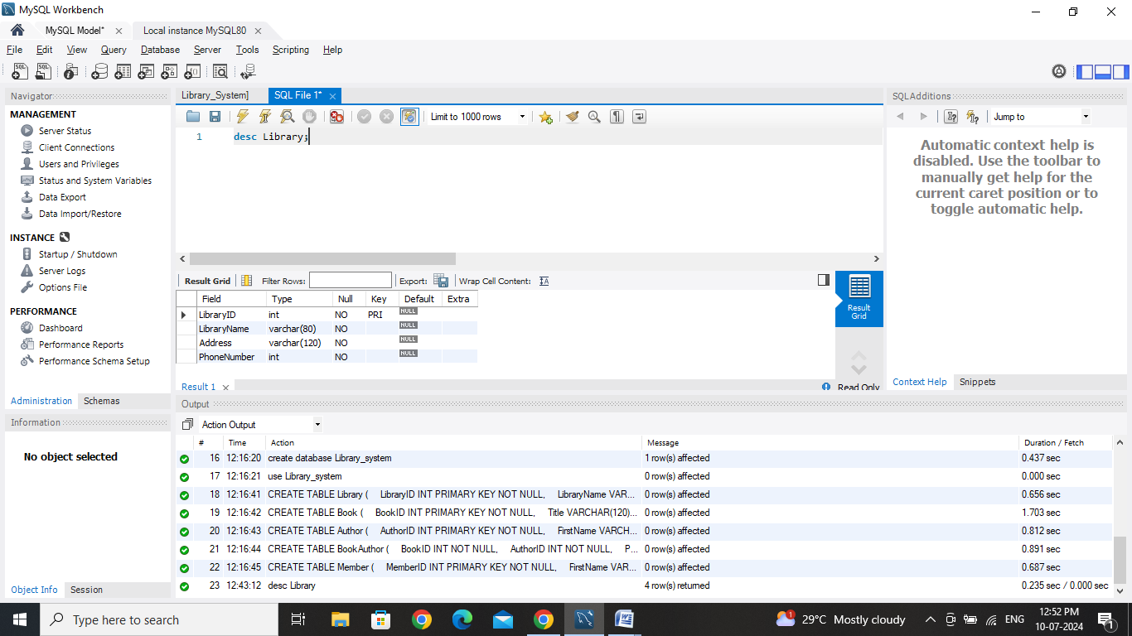

Fields in Library Table:

* LibraryID : Primary Key, int, NOT NULL
* LibraryName : varchar(80), NOT NULL
* Address : varchar(120), NOT NULL
* PhoneNumber: int, Checks Should be in PhoneNumber 9 AND PhoneNumber <= 13

**Book Table:**

CREATE TABLE Book (

BookID INT PRIMARY KEY NOT NULL,

Title VARCHAR(120) NOT NULL,

ISBN VARCHAR(13) UNIQUE NOT NULL,

Publisher VARCHAR(100) NOT NULL,

YearPublished int NOT NULL,

LibraryID INT NOT NULL,

FOREIGN KEY (MemberID) REFERENCES Member(MemberID)

FOREIGN KEY (LibraryID) REFERENCES Library(LibraryID)

);

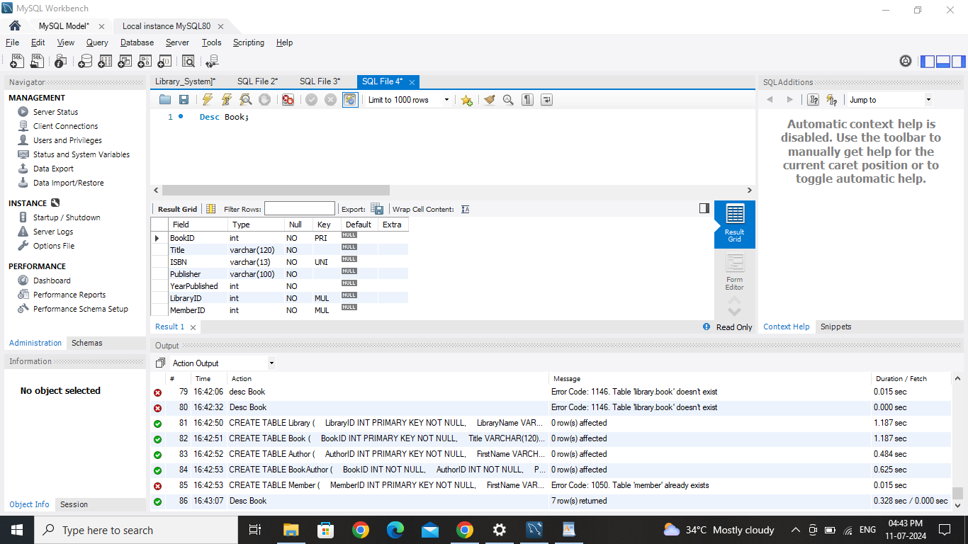

Fields in Book Table:

* BookID : Primary Key, Int, NOT NULL
* Title : varchar(120), NOT NULL
* ISBN : varchar(13), UNIQUE, NOT NULL
* Publisher : varchar(100), not null
* YearPublished : Int
* LibraryID : Foreign Key, INT, NOT NULL
* MemberID: Foreign Key, INT, NOT NULL

**Author Table:**

CREATE TABLE Author (

AuthorID INT PRIMARY KEY NOT NULL,

FirstName VARCHAR(20) NOT NULL,

LastName VARCHAR(20) NOT NULL,

Author_phn INT

);

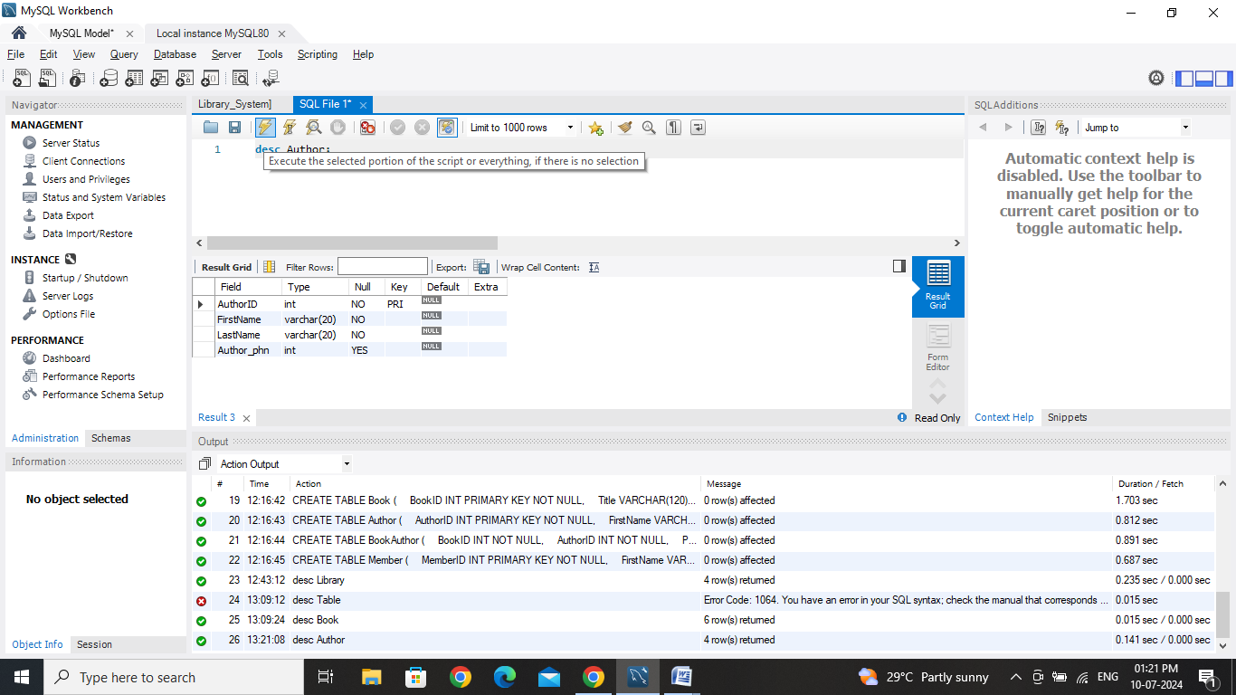

Fields in Book Table:

* AuthorID : Primary Key, Int, NOT NULL
* FirstName : varchar(20), NOT NULL
* LastName : varchar(20), NOT NULL

**Member Table :**

CREATE TABLE Member (

MemberID INT PRIMARY KEY NOT NULL,

FirstName VARCHAR(20) NOT NULL,

LastName VARCHAR(20) NOT NULL,

Email VARCHAR(40) UNIQUE NOT NULL,

PhoneNumber INT check (PhoneNumber > 9 AND PhoneNumber <= 13) NOT NULL

);

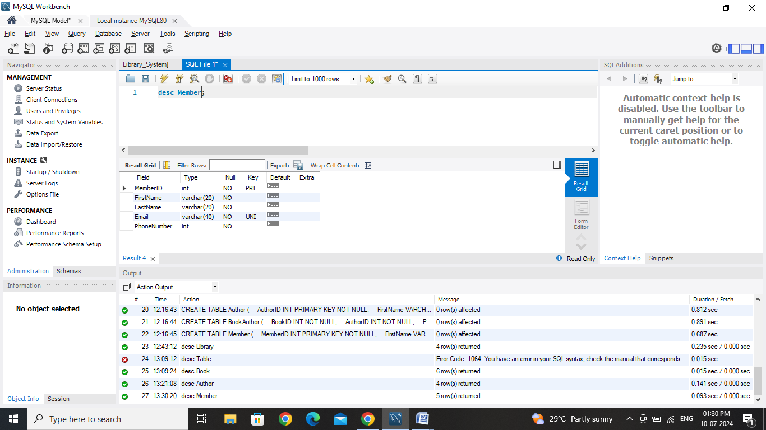

Fields in Member Table:

* MemberID (Primary Key, Int, NOT NULL)
* FirstName (varchar(20), NOT NULL)
* LastName (varchar(20), NOT NULL)
* Email (VARCHAR(40), UNIQUE, NOT NULL)
* PhoneNumber: Int, Checks Should be in PhoneNumber 9 AND PhoneNumber <= 13

**BookAuthor Table :**

CREATE TABLE BookAuthor (

BookID INT NOT NULL,

AuthorID INT NOT NULL,

PRIMARY KEY (BookID, AuthorID),

FOREIGN KEY (BookID) REFERENCES Book(BookID),

FOREIGN KEY (AuthorID) REFERENCES Author(AuthorID)

);

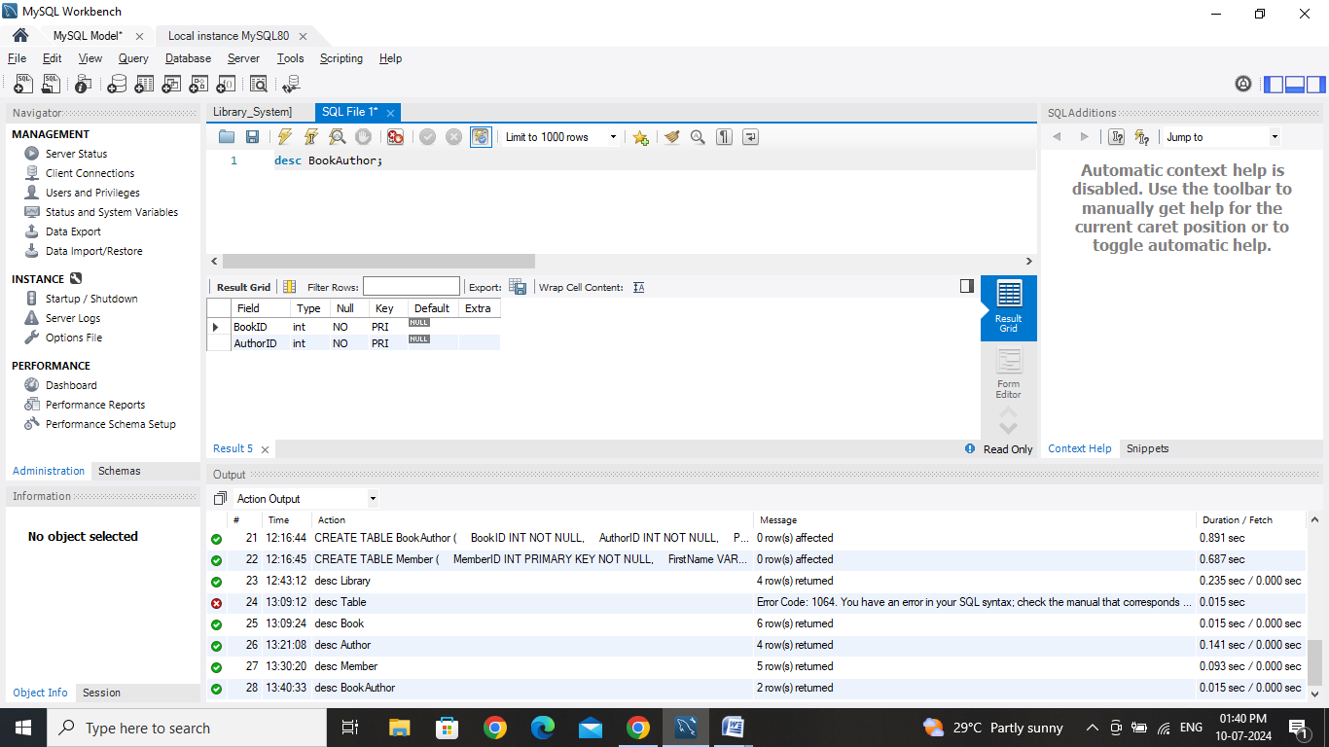

Fields in BookAuthor Table:

* BookID : Foreign Key, Int, NOT NULL
* AuthorID : Foreign Key, Int, NOT NULL
* PRIMARY KEY: BookID, AuthorID

**ALTER and DROP:**

Alter is used to modify the existing table. Drop is used to remove the existing table.

**ALTER**

Modifying the **Book** Table by adding a new column “Book_Type”.

Modifying the **Member** Table by adding a new column “Membership”.

**DROP**

Removing **BookAuthor** Table.

**ALTER COMMANDS:**

ALTER TABLE Book ADD Genre VARCHAR(50);

ALTER TABLE Member ADD MembershipStatus VARCHAR(10);

**Book Table :**

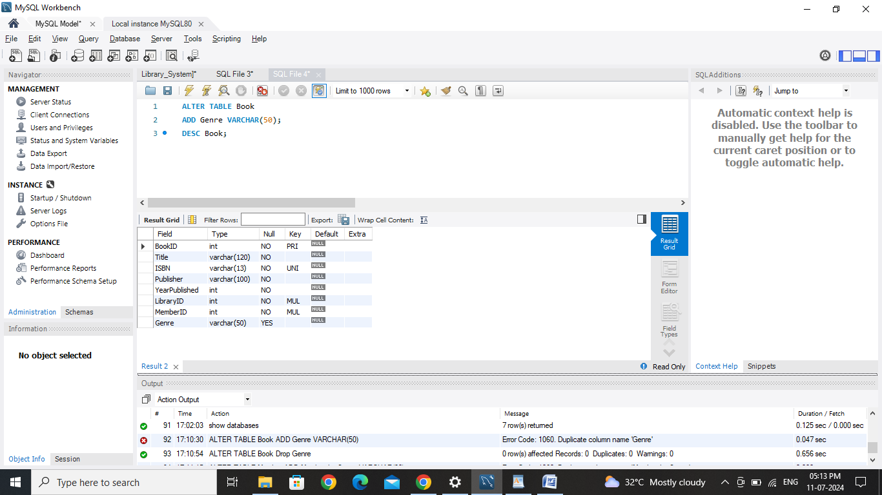

Genre was added in Book Table.

**Member Table :**

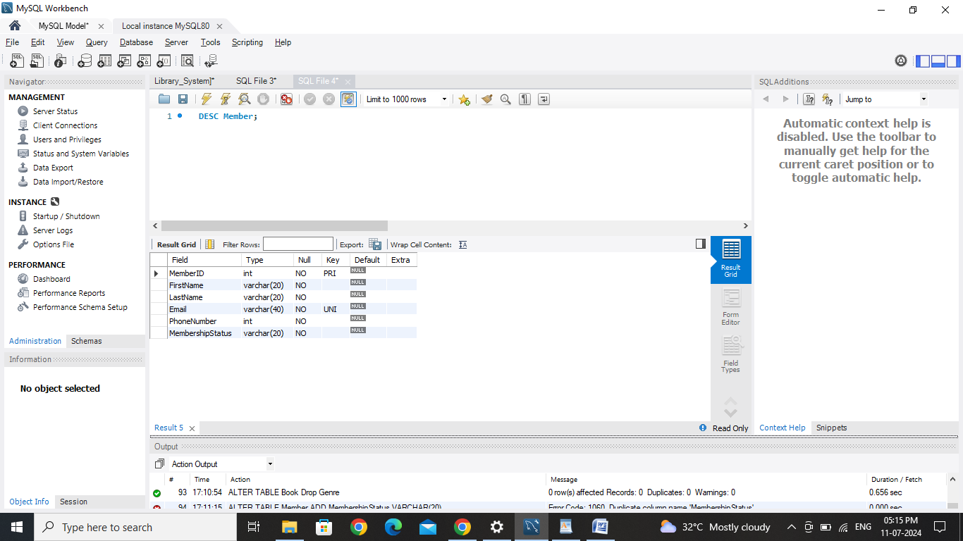

MembershipStatus columns was added in Member Table

**DROP COMMAND:**

DROP TABLE BookAuthor;

SHOW TABLES;

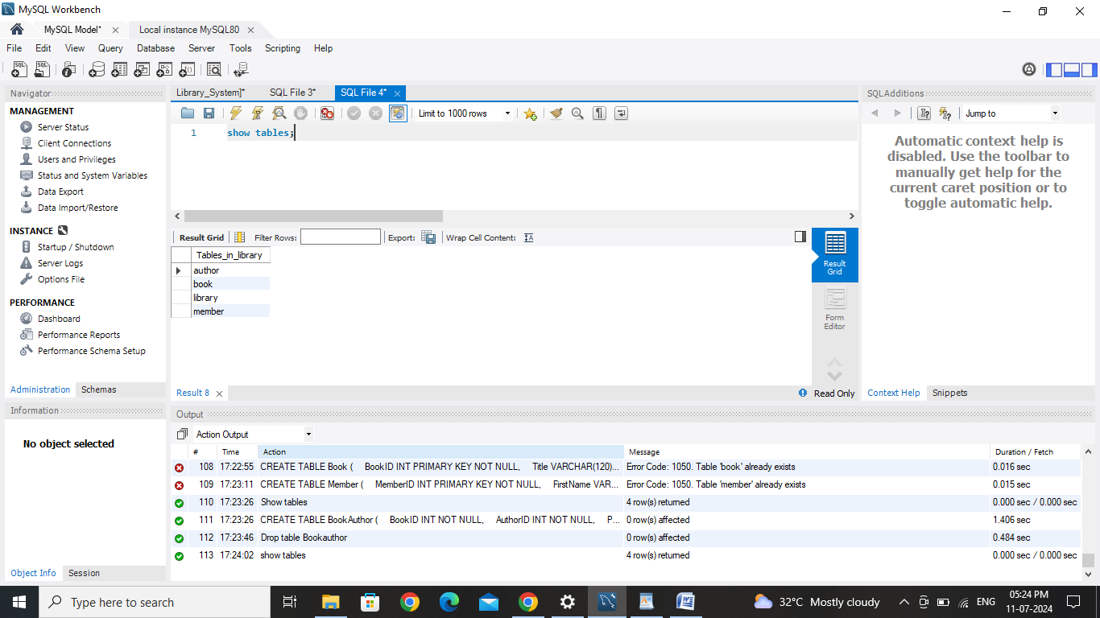

BookAuthor Table was removed by using Drop Command.

**UPDATED TABLES:**

**Author Table:**



**Book Table:**



**Member Table:**



**Library Table:**

